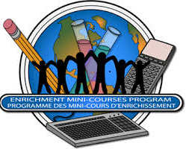
ENRICHMENT MINI-COURSES PROGRAM
FOR
STUDENTS IN GRADES 8- 11

WOULD YOU LIKE TO ATTEND UNIVERSITY FOR A WEEK IN MAY TO STUDY ONE OF THE FOLLOWING SUBJECTS?

LITERATURE
DRAMA, FILM, MUSIC
JOURNALISM, SOCIOLOGY, CRIMINOLOGY
MATHEMATICS, COMPUTER SCIENCE, LAW
POLITICS, RELIGION, WORLD AFFAIRS

HERE’S YOUR CHANCE!!

DATES: MAY 6 – 10, 2019
TIMES: 9:00 AM – 3:00 PM EACH DAY
COST: To be confirmed.

TRANSPORTATION TO AND FROM THE POST-SECONDARY SITE IS THE RESPONSIBILITY OF THE FAMILIES OF PARTICIPATING STUDENTS.

For more information, please consult your school EMCP representative:

Ms McCallum in Guidance
____________________________________________________________

